Personal Technology Plan
CEP 812
Lial Miller
5 August 2009

I am the last person you should ask about the implementation of technology in the classroom. I am not a technological native, immigrant or even much of a tourist. I am a technological dinosaur. I still do math in my head; calculators are just to verify the answer. I have only had a computer for eight years, and I am forty-three years old. That leaves me starting off thirty-five years behind the curve. The only reason I have a cell phone is because my family wanted to get out of the Stone Age. In other words, I just do not believe in technology very much.
The main reason I am against technology is because it makes people quit thinking for themselves. Not in whole, but in theory. People have quit reading the newspaper and books like the Encyclopedia and Dictionaries. People rely on computers to tell them how much change to return to the customer after a purchase. If it were not for Spell Check, a lot of students would not know how to write a complete sentence, let alone a quality paragraph. I think technology should be used in a supportive roll, to back up prior knowledge. There is nothing wrong with learning the hard way and substantiating the answer, checking it to make sure it is right.
There are other reasons I am not totally pro-technology in the classroom. Technology costs too much. It breaks down, or is outdated too fast. By the time you get used to it, or the students learn how to use a particular component, or software, something better has come along, making the prior obsolete. Since the costs are too high, the school is left using an old program, or computer and the students are virtually falling behind because they are not using the best equipment available. People intentionally destroy through hacking or viruses. I have had students that tried to see how technologically advanced I was by flipping over monitor images and stealing the balls out of their navigational mouse. I am writing this paper with a pop-up note saying my computer has a “Trojan.Mdropper.AC” virus. Why? If people have the knowledge to work on/with computers, why do they feel the need to mess up other people’s lives? It is going to cost me money I do not have to have somebody restore my computer. There are many different reasons to not use technology in the classroom and it all brings upon comment/question: In the final result, is the end result worth the means in getting there?
Now, I need to put the proverbial shoe on the other foot. If it were not for my computer, I would not have nearly as many cool art lessons I could teach the children. I constantly look at web pages like http://www.artsonia.com or http://www.crayola.com to generate fresh lesson ideas. I have developed a lesson on Dada Art that has the students using the internet to perform a research portion, followed up with a typewritten essay. I would like to be able to include more lessons with research portions, but, as a traveling art teacher, the access to technology is hard for me to come by.
Most teachers are given a computer for their rooms. They use it during their planning period and create future lessons, or update grades (if necessary). If a teacher is technologically savvy, they find ways of having that computer drive other components in the classroom; an image projector, or an mp3 player. As a specialist, I have no room to claim as my own. I do have an “office” at another location, but how am I supposed to use that for lesson development, or lesson distribution? I bought a laptop just so I could take it to school and have some form of technology at my disposal, but it gets real heavy by the end of the school year. I have to plan my lessons at home (I know….all teachers do to some extent). I have to download grading programs and update student progress on my own time. As a traveling teacher, I get to know and implement three different grading programs to be used at six different schools. Plus, I get to keep up the grades of almost 600 students. E-mail is a wonderful way to keep in contact with the parents, but the only ones that use it are the parents that have a dislike to their child’s progress and verbal liberties are taken, trying to rip me a “new one.” Oh, how I would love it to get an e-mail from a parent saying how much Johnny, or Suzie likes being in my class.
Each school has a computer lab at my disposal, which is a great thing. But, every time I sign up to use it, I am bumped out because a regular classroom teacher wanted to use it at the same time. I could sign up a month in advance and get taken out the morning I planned on using the lab. Sometimes it just comes down to scheduling. If I have two third grade classes, but I get to meet with one of the classes during a forth grade “computer time,” how do I teach a lesson equally to those third grade students? Does one class perform the research portion and the other class just the physical aspect? It would not be fair to either side and the lesson usually gets put on hold.
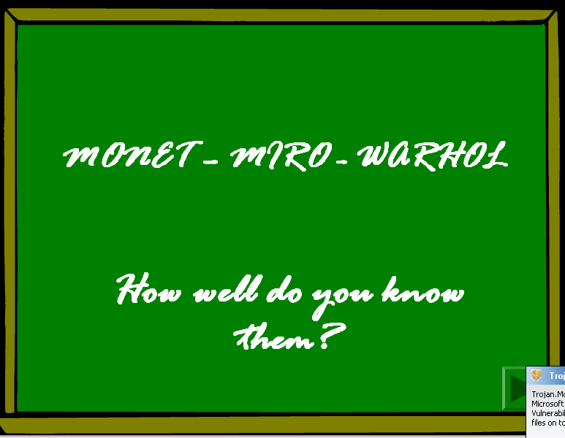
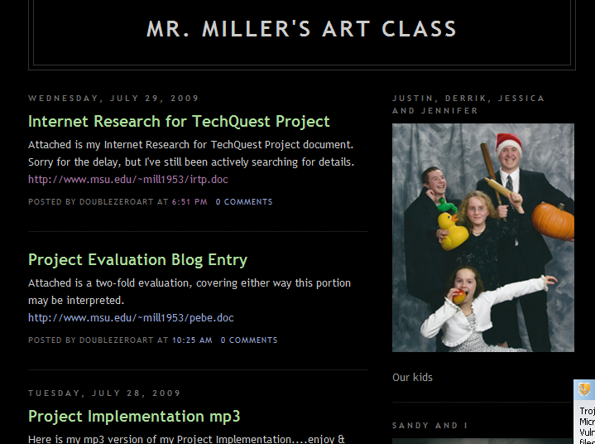
If I do finally gain the use of the computer lab, it is for a short burst of time and usually limited to strictly internet research. I am not that well versed at PowerPoint or Excel programs. Until a few weeks ago a web page was something I visited and left behind; only using about ten web sites on a regular basis. This made my lessons boring and a simple “just get it over with” assignment. I knew this was a personal weakness, so I addressed it by taking CEP classes here at Michigan State University. The first class taught the basics of Word, Excel, and PowerPoint. The next class had me developing personal (http://www.msu.edu/~mill1953) and instructional web pages (http://www.msu.edu/~mill1953/artheist) and a blog page (http://mrmillersartclass.blogspot.com), coupled with a “StAIR” PowerPoint presentation (https://www.msu.edu/~mill1953/docs/lesson6.ppt). I can see how easy a blog page would help me stay in contact with my students and their parents. It would be a very positive way for them to keep up on what is going on in class without using expensive paper. The “StAIR” I made demonstrated how I could use PowerPoint in a classroom to give a quiz, without the students fearing public embarrassment if they produced a wrong answer to one of my questions. I watched as my classmates used their “StAIR” projects to teach subjects deeper than they probably ever tried. The information was right at the user’s fingertips and reinforcement/redirection was given if you strayed off the course of the “StAIR.” My web page is kind of boring to me, but I have never been one to blow my own horn. I learned how to link items and to develop better aesthetics, making my web page more appealing to the eye. Now the problem is what to do to keep it updated and relevant for my class. The instructional web page, called a WebQuest, is an electronic scavenger hunt. Students are directed that they will become art detectives, searching for clues left behind by a fictional thief. All of the clues lead the students to an anagram of the thief’s name and location of the missing paintings. As the students finish the WebQuest, they will be virtually taken from Denmark and Spain, through the United States of America, down to Brazil and Mexico. The students will learn about different cultures and foreign language. They will also gain knowledge of six different artists, to which they must discern that they all just happen to be Spanish in nationality. I like the idea behind the WebQuest and have received a lot of positive comments about the overall concept. I am positive the students will enjoy the challenge when I get the opportunity to present the WebQuest to them.
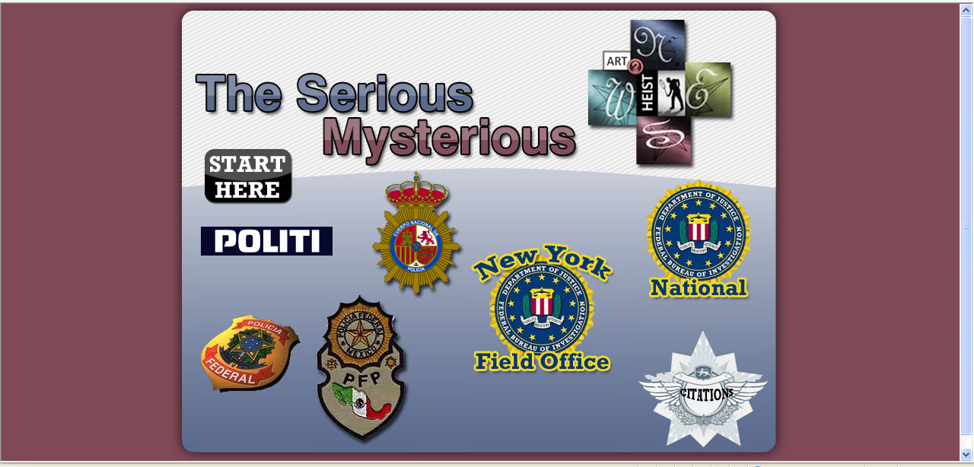

In the third class, I chose to develop all of the details as if I were trying to obtain Grant funding for something called a “Smart Cart.” If, or when, I follow through with my attempt to get at least one “Smart Cart,” I would make my technological teaching life much better. A “Smart Cart” would address all of my electronic needs, condensed into one 2’X3’ box that stands 4’ tall. A “Smart Cart” is a portable technology center that has:
- Computer with internet access (Wireless or Ethernet)
  - Dell Optiplex System
- Video Projection System - *=Optional Pieces
  - Video Projector
    - Boxlight Seattle X35N 3500 ANSI Lumens LCD*
    - Epson V12H162020 High Resolution Document Imager*
  - Video Screen
    - Dalite 84815 10’X13’ Fastfold Truss Screen*
    - Panasonic Electronic Whiteboard PWB1025*
- DVD/VCR Player
  - Sony SLVD380P
- Student Response System
  - I-Clicker with 40 to 50 Remotes
- Cart
  - Oklahoma Sound Smart Cart Lectern, Mahogany
- Remote Control
  - Creston Universal Remote
Additions and changes can be made as time goes by, or needs change. The use of a “Smart Cart” is limitless; it can flow with every person’s need.
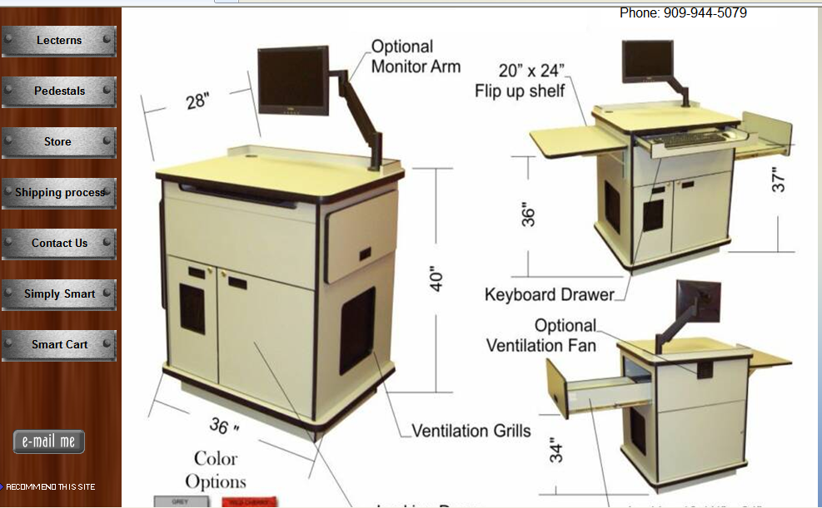

Once a “Smart Cart” is obtained, loaded and wired it would last for years, if kept in good condition. We all know how community property is abused and left to go to the waste pile. The only thing that would become outdated would be the computer, and if that is set up properly, could act as the brains of the outfit for a decade, or longer.
One of the main setbacks to the “Smart Cart” is that there is only one of them. If a lesson were to be set up for the students to perform any research, I would still be subject to the computer lab usage rules as before. The students would be in a bread-line trying to get their hands on the computer to do their work. Another pitfall would be the inevitable breakdown of equipment. Once a component wears down, will the school have the means to replace it? Personally, I think the positives outweigh the negatives greatly, but then again, I am biased to this project. Plus, it is a proven technology, with many other institutions already using the “Smart Cart.” Some that I have found are:
- Ohio University Southern - http://www.southern.ohiou.edu/pages/faculty-staff/technology/technology-faq.html
- Temple University - http://www.temple.edu/cs/cts/for_credit_courses.htm
- Burlington County College - http://staff.bcc.edu/ETC/karts1.htm
- Delta State University - http://www.deltastate.edu/pages/1822.asp
- The University of Alaska Anchorage - http://www.matsu.alaska.edu/campusResources/computerServices/smartCarts.htm

There is no real time line for the “Smart Cart.” It is a work in progress and flows with the needs of the teacher, or school. The hardest part would be getting the cart, after that, it becomes all-serving and you can find an endless amount of ideas in ways to use it. As long as the components are kept in good working order, the “Smart Cart” will be ready to serve at a moment’s notice and last for years. As time goes by, I would seek individual training from those with experience on/with the components within the “Smart Cart.” I would research upcoming computer/electronics seminars, so I could keep myself up on the latest technology and learn how to operate the current components better. The main thing I would have to do is listen to fellow teachers as they gave suggestions to things that may be added, making the “Smart Cart” smarter. Once in place, more StAIR lessons can be developed and implemented in the classroom. Additional WebQuests may be developed, helping the students get out of the rut of 1970’s learning styles and into the 21st century. I could also use my planning time to keep my web page and blog page updated, keeping the students and their parents current with class happenings.
It takes a lot to sell a dinosaur something it does not need, but I can definitely see how much easier a “Smart Cart” would make teaching, at least in my realm as a traveling teacher. How much a “Smart Cart” gets used is strictly up to its access. If it is available (if I were to obtain funding, I would lay claim to it….not controlling, but overseeing) I would use it as an educational tool. If it is over-used, it would lose its effectiveness and the students would become bored of seeing it. If it is used too little, the time and energy spent to obtain it would become a waste. But, if used in moderation, it would be as Goldie Locks would say, “…just right.”

REFERENCES

http://www.artsonia.com – Reference only – 5 August 2009
http://www.crayola.com – Reference only – 5 August 2009
http://www.msu.edu/~mill1953 – Reference only – 5 August 2009
http://www.msu.edu/~mill1953/artheist – Reference only – 5 August 2009
http://mrmillersartclass.blogspot.com – Reference only – 5 August 2009
https://www.msu.edu/~mill1953/docs/lesson6.ppt – Reference only – 5 August 2009
“Smart Cart” image/concept - http://www.avsmartcart.com/index.html - Reference only –
5 August 2009
Ohio University Southern - http://www.southern.ohiou.edu/pages/faculty- staff/technology/technology-faq.html – Reference only – 5 August 2009
Temple University - http://www.temple.edu/cs/cts/for_credit_courses.htm – Reference
only – 5 August 2009
Burlington County College - http://staff.bcc.edu/ETC/karts1.htm – Reference only – 5
August 2009
Delta State University - http://www.deltastate.edu/pages/1822.asp – Reference only – 5
August 2009
The University of Alaska Anchorage –
http://www.matsu.alaska.edu/campusResources/computerServices/smartCarts.htm – Reference only – 5 August 2009

